Summary
Feature Everyday Analogy Why it matters
Context Window Desk Size Determines if the AI can remember a whole book or just a few pages.
Input The Reading List You are charged for how much you ask the AI to "listen" to.
Output The Final Report You are charged for how much the AI "speaks" or writes.

groq Multimodels details
Model Name Context Window Input Cost (per 1M tokens) Output Cost (per 1M tokens)
Llama 3.2 11B Vision 128,000 tokens $0.05 $0.05
Llama 3.2 90B Vision 128,000 tokens $0.59 $0.79
Llama 3.3 70B Versatile 128,000 tokens $0.59 $0.79
GPT-OSS 120B 128,000 tokens $0.15 $0.60

Open AI router Multimodal details

Multimodal Model Specifications & Pricing
Model Name Context Window Input Cost (per 1M) Output Cost (per 1M)
Grok 4.1 Fast 2,000,000 tokens $0.20 $0.50
Sonoma Dusk Alpha 2,000,000 tokens Free (Alpha) Free (Alpha)
Gemini 2.5 Flash 1,048,576 tokens $0.30 $2.50
Nemotron Nano 12B 2 VL 256,000 tokens $0.20 $0.60

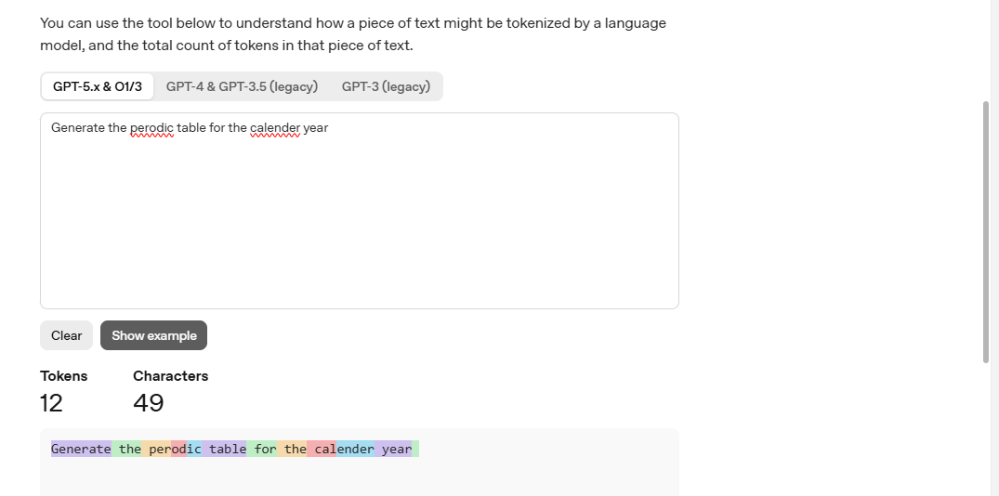

The Breakdown of Your Sentence
Here is how the AI "chopped up" your specific text:
- Generate (1 token): A very common word, so it stays as one piece.
- [space]the (1 token): The AI usually bundles a space with the word following it.
- [space]per (1 token) + odic (1 token): Notice you misspelled "periodic" as "perodic." Because the AI doesn't recognize the misspelling as a standard single word, it breaks it into two smaller pieces it does know.
- [space]table (1 token)
- [space]for (1 token)
- [space]the (1 token)
- [space]cal (1 token) + end (1 token) + er (1 token): Again, "calender" is a misspelling (should be calendar). The AI had to use three "bricks" to build this misspelled word.
- [space]year (1 token)
- [Hidden/Trailing Space] (1 token): The tool shows 12 tokens even though the visible words only account for 11; this is usually because there is an invisible "end of text" character or a space after the word "year."

Why did it generate 12 tokens instead of just 8 words?
- The "Misspelling Penalty": When you spell a word correctly (like "periodic"), the AI can often use 1 token. When you misspell it, the AI has to use multiple smaller tokens to "spell it out" phonetically. This is why "calender" took 3 tokens.
- Spaces are Characters too: In AI logic, a space is just as important as a letter. Most tokenizers attach the space to the front of the word.
- Commonality: The more common a sequence of letters is in the English language, the more likely it is to be a single token.
Why this matters for you
Since you pay per token (as we discussed earlier), misspellings actually make your AI usage more expensive.
In this example, if the words were spelled correctly, the token count would likely drop from 12 to 9 or 10, saving you about 20% on the cost of that specific sentence!

